 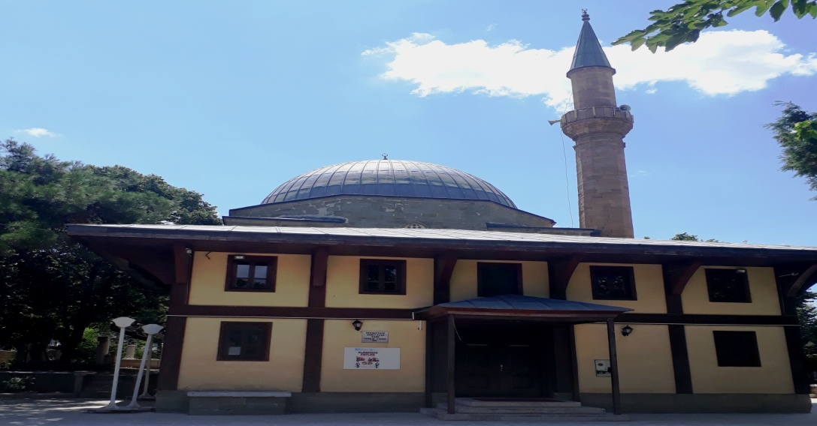

**KEŞAN İLÇE MÜFTÜLÜĞÜ**  
Mustafa Kemal Paşa Mahallesi Beyaz Sk.No:9  KEŞAN

Tel: (0 284) -714 12 69 Faks:(0 284) -714 77 59 E-posta:  kesan@diyanet.gov.tr

|  |  |  |  |  |  |  |  |  |
| --- | --- | --- | --- | --- | --- | --- | --- | --- |
| **KEŞAN 2020 YILI RAMAZAN İMSAKİYESİ** | | | | | | | | |
| **HİCRİ AY** | **MİLADİ AY** | **GÜN** | **İMSAK** | **GÜNEŞ** | **ÖĞLE** | **İKİNDİ** | **AKŞAM** | **YATSI** |
| 01 RAMAZAN | 24 NISAN | CUMA | 04 39 | 06 14 | 13 17 | 17 04 | 20 09 | 21 38 |
| 02 RAMAZAN | 25 NISAN | CUMARTESİ | 04 37 | 06 13 | 13 16 | 17 04 | 20 10 | 21 39 |
| 03 RAMAZAN | 26 NISAN | PAZAR | 04 35 | 06 11 | 13 16 | 17 05 | 20 11 | 21 41 |
| 04 RAMAZAN | 27 NISAN | PAZARTESİ | 04 33 | 06 10 | 13 16 | 17 05 | 20 12 | 21 42 |
| 05 RAMAZAN | 28 NISAN | SALI | 04 32 | 06 09 | 13 16 | 17 05 | 20 13 | 21 44 |
| 06 RAMAZAN | 29 NISAN | ÇARSAMBA | 04 30 | 06 07 | 13 16 | 17 05 | 20 14 | 21 45 |
| 07 RAMAZAN | 30 NISAN | PERŞEMBE | 04 28 | 06 06 | 13 16 | 17 06 | 20 15 | 21 47 |
| 08 RAMAZAN | 01 MAYIS | CUMA | 04 26 | 06 05 | 13 16 | 17 06 | 20 17 | 21 48 |
| 09 RAMAZAN | 02 MAYIS | CUMARTESİ | 04 24 | 06 03 | 13 16 | 17 06 | 20 18 | 21 50 |
| 10 RAMAZAN | 03 MAYIS | PAZAR | 04 23 | 06 02 | 13 15 | 17 07 | 20 19 | 21 51 |
| 11 RAMAZAN | 04 MAYIS | PAZARTESİ | 04 21 | 06 01 | 13 15 | 17 07 | 20 20 | 21 53 |
| 12 RAMAZAN | 05 MAYIS | SALI | 04 19 | 06 00 | 13 15 | 17 07 | 20 21 | 21 54 |
| 13 RAMAZAN | 06 MAYIS | ÇARSAMBA | 04 17 | 05 59 | 13 15 | 17 07 | 20 22 | 21 56 |
| 14 RAMAZAN | 07 MAYIS | PERŞEMBE | 04 16 | 05 57 | 13 15 | 17 08 | 20 23 | 21 57 |
| 15 RAMAZAN | 08 MAYIS | CUMA | 04 14 | 05 56 | 13 15 | 17 08 | 20 24 | 21 59 |
| 16 RAMAZAN | 09 MAYIS | CUMARTESİ | 04 12 | 05 55 | 13 15 | 17 08 | 20 25 | 22 00 |
| 17 RAMAZAN | 10 MAYIS | PAZAR | 04 11 | 05 54 | 13 15 | 17 09 | 20 26 | 22 02 |
| 18 RAMAZAN | 11 MAYIS | PAZARTESİ | 04 09 | 05 53 | 13 15 | 17 09 | 20 27 | 22 03 |
| 19 RAMAZAN | 12 MAYIS | SALI | 04 08 | 05 52 | 13 15 | 17 09 | 20 28 | 22 05 |
| 20 RAMAZAN | 13 MAYIS | ÇARSAMBA | 04 06 | 05 51 | 13 15 | 17 09 | 20 29 | 22 06 |
| 21 RAMAZAN | 14 MAYIS | PERŞEMBE | 04 04 | 05 50 | 13 15 | 17 10 | 20 30 | 22 08 |
| 22 RAMAZAN | 15 MAYIS | CUMA | 04 03 | 05 49 | 13 15 | 17 10 | 20 31 | 22 09 |
| 23 RAMAZAN | 16 MAYIS | CUMARTESİ | 04 01 | 05 48 | 13 15 | 17 10 | 20 32 | 22 11 |
| 24 RAMAZAN | 17 MAYIS | PAZAR | 04 00 | 05 47 | 13 15 | 17 11 | 20 33 | 22 12 |
| 25 RAMAZAN | 18 MAYIS | PAZARTESİ | 03 58 | 05 46 | 13 15 | 17 11 | 20 34 | 22 14 |
| 26 RAMAZAN | 19 MAYIS | SALI | 03 57 | 05 45 | 13 15 | 17 11 | 20 35 | 22 15 |
| **KADİR GECESİ** | | | | | | | | |
| 27 RAMAZAN | 20 MAYIS | ÇARSAMBA | 03 56 | 05 45 | 13 15 | 17 11 | 20 36 | 22 17 |
| 28 RAMAZAN | 21 MAYIS | PERŞEMBE | 03 54 | 05 44 | 13 15 | 17 12 | 20 36 | 22 18 |
| 29 RAMAZAN | 22 MAYIS | CUMA | 03 53 | 05 43 | 13 15 | 17 12 | 20 37 | 22 19 |
| 30 RAMAZAN | 23 MAYIS | CUMARTESİ | 03 52 | 05 42 | 13 15 | 17 12 | 20 38 | 22 21 |
| **24 MAYIS PAZAR RAMAZAN BAYRAMININ 1.GÜNÜ** | | | | | | | | |
| **BAYRAM NAMAZ VAKTİ: 06 23** | | | | | | | | |

**2020 Yılı Fitre Bedeli 27,00.TL**

**FAKİR ÖĞRENCİLERE VE AİLELERE VERİLMEK ÜZERE TÜRKİYE DİYANET VAKFI KEŞAN ŞUBEMİZCE AÇILAN HESAPLARA; BAĞIŞ, FİTRE VE ZEKATLARINIZI YATIRABİLİRSİNİZ.**

**TÜRKİYE DİYANET VAKFI HALK BANKASI KEŞAN ŞUBESİ**

**BAĞIŞ : TR39 0001 2009 3370 0010 2603 20**

**FİTRE : TR13 0001 2009 3370 0016 0000 84**

**ZEKAT: TR83 0001 2009 3370 0016 0000 85**